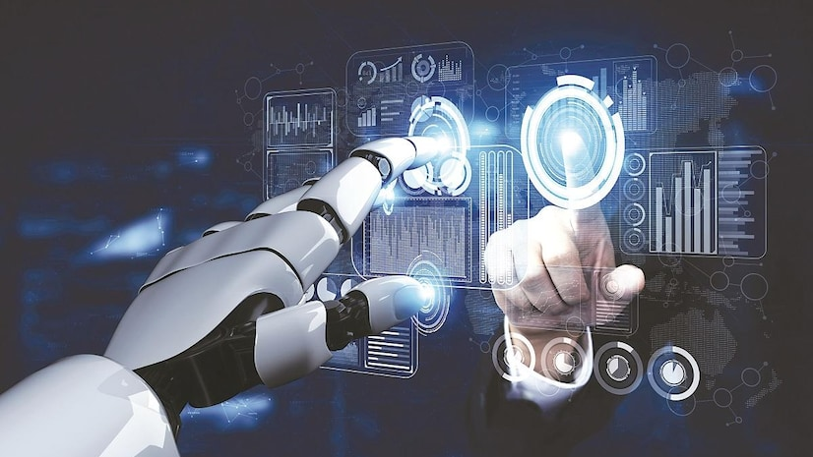***NATIONAL ARTIFICIAL INTELLGENCE (AI) DAY***

This National 'Ai' Day, celebrated on April 26, you'll get to learn about the meaning behind this Chinese and Japanese word. 'Ai' means 'adoration,' 'affection,' or 'love.'

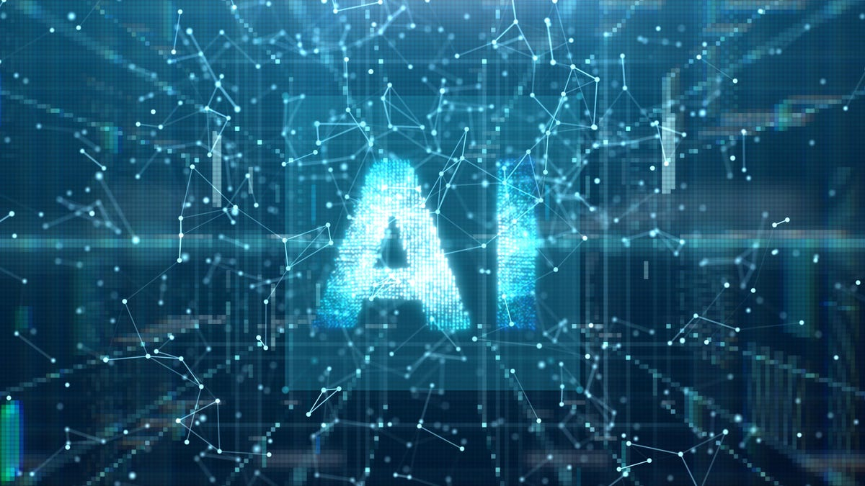**This National ‘Ai’ Day, celebrated on April 26, you’ll get to learn about the meaning behind this Chinese and Japanese word. ‘Ai’ means ‘adoration,’ ‘affection,’ or ‘love.’ The word is used almost exclusively as a female name in Japan, but boys are sometimes given it in Chinese too. Notable figures such as Ai Wei Wei, Ai Sugiyama, and Ai Otsuka share this name, and dozens of videogames, cartoons and fantasy characters with the name appear across Japanese and Chinese media. It’s pronounced similar to the word ‘eye’ in both cultures, but the kanji (Japanese) inscriptions differ from the hanzi (Chinese) characters.**

Ai Otsuka is a Japanese singer-songwriter famous for her song “Sakuranbo,” released in 2003. The 39-year-old musician was a child prodigy who began playing the piano at age four and writing songs in her teens. Trained as nursery teachers, Otsuka and her former classmate Mami Nishida

 started to record and upload music online in the early 2000s, sending demo tapes to studios with little success. In 2003 the popularity of “Sakuranbo” got Otsuka signed to Avex Trax, one of Japan’s biggest record labels. In 2004 she released her debut album “Love Punch,” which peaked at number three on Japanese music charts and sold nearly 200,000 copies in its first week.



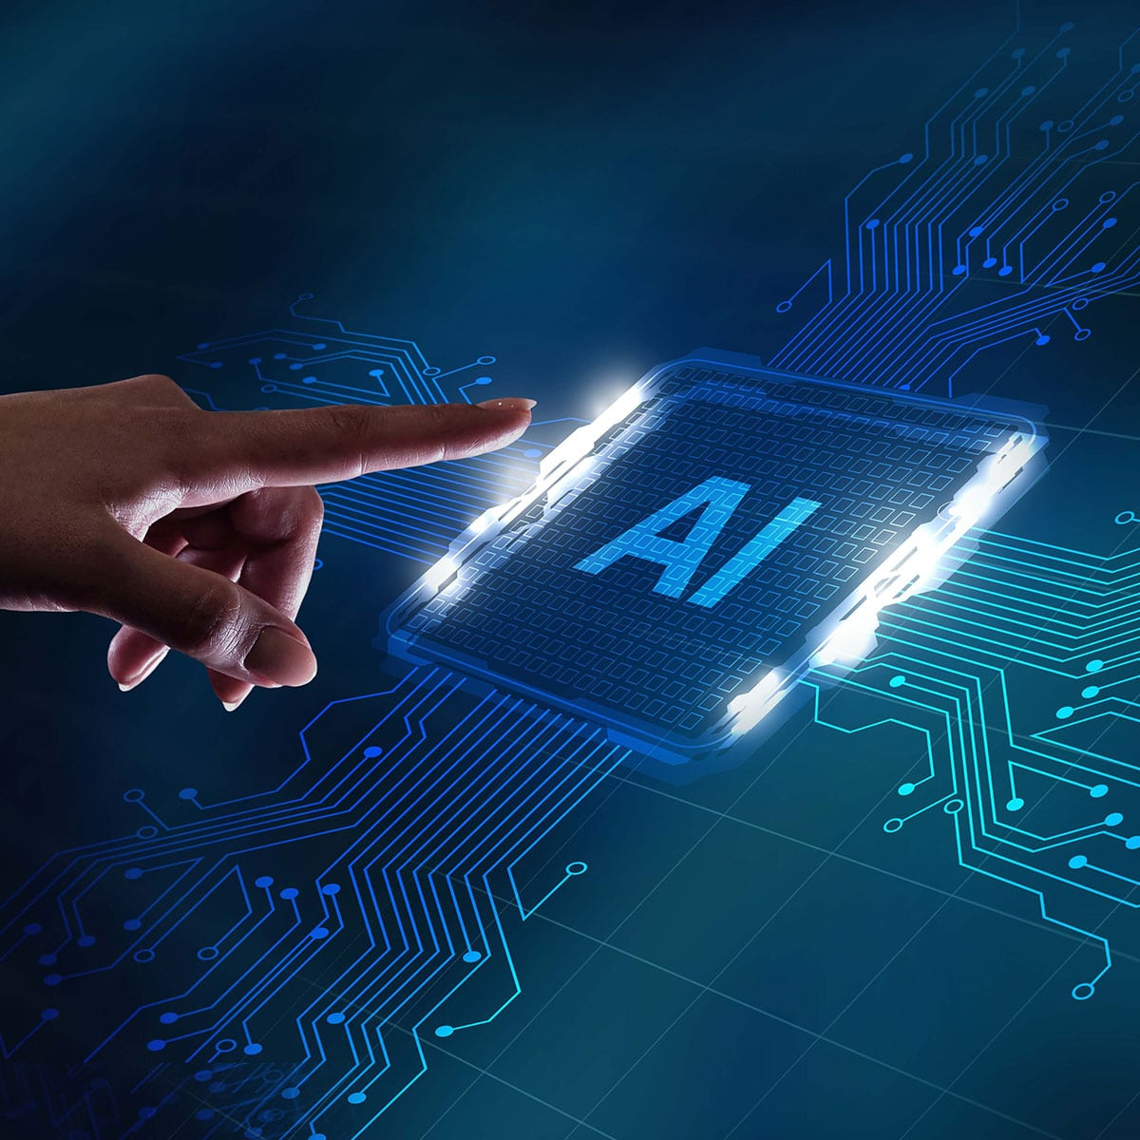

Artificial intelligence first appeared as a storytelling device and has since been prominent in fiction, like in Mary Shelley’s Frankenstein. Many of the same questions that are now being explored in the ethics

of artificial intelligence were highlighted by these individuals and their fates.

Mechanical reasoning was first studied by philosophers and mathematicians in the 1900s. The research of formal logic ultimately led to Alan Turing’s idea of computation. He proposed that a machine could replicate any conceivable act of logical deduction by manipulating the symbols ‘0’ and ‘1.’ The Church–Turing thesis is the idea that digital computers can imitate any formal reasoning process.

